1. Thi viết trên Word. Có thể dùng paint để vẽ hoặc dùng Excel để viết, sau đó chụp hình màn hình đưa sang Word

Data: 1 1 0 1 1 1

G1: x3 + x2 + 1 <=> 1 1 0 1

Because the polynomial generator has 4 bits. Therefore, we add 3 bits to the end of data bit string.

We have: 1 1 0 1 1 1 0 0 0

Then we take these bits and divide to 1 1 0 1 in module – 2 method.

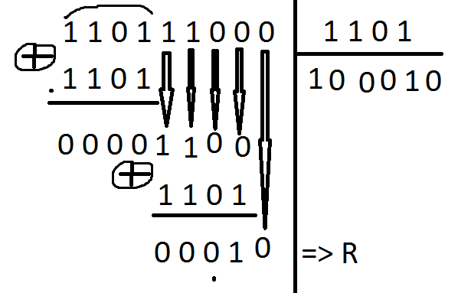

Result: R = 010 and the codeword is

1 1 0 1 1 1 0 1 0

=============

Checksum

VD: Data

0000000001110111

1111110111010101

0101110101110001

0000000001110111 1111110111010101 0101110101110001 1010010001000001

================

Câu về địa chỉ IP và định tuyến

Take 22 first bits of the IP address 135.46.63.10

135.46.60.0

We found that 22 first bits of the IP address is match with the address of Interface 1.

Therefore, router will forward the packet to Interface 1.